

# A PROJECT REPORT ON

Career Connect: Job Portal Application

**Submitted in partial fulfillment for Degree of**

MASTER OF COMPUTER APPLICATIONS

**By**

**Mr. Pandurang D. Shirsat Mr. Onkar R. Malwade**

**Under the guidance of**

**Prof. Minaxi P. Gurav (Department of MCA)**



# FINOLEX ACADEMY OF MANAGEMENT AND TECHNOLOGY, RATNAGIRI

**This is to certify that the project report titled:**

**Career Connect: Job portal Application**

**Submitted By:**

**Mr. Pandurang D. Shirsat Mr. Onkar R. Malawade**

**In partial fulfillment of the award for degree of**

**MASTER OF COMPUTER APPLICATIONS**

**From Mumbai University**

**And are the bonafide record of the work done by them during the Semester III of SY 2024-2025**

**Internal Guide HOD**

**(Prof. Minaxi Gurav) (Prof. Tejas Joshi)**

## ACKNOWLEDGEMENT

We wish to express our sincere thanks to The Principal Dr. Kaushal Prasad and HOD of Department of Master of Computer Applications Mr. Tejas V. Joshi for their support and for the facilities they have made available. We thank our guide, Prof. Minaxi P. Gurav for her enthusiasm, patience, insightful comments, helpful information, practical advice and unceasing ideas that have helped us tremendously at all times.

We are also grateful to the staff of the Department of Master of Computer Applications for their consistent support and assistance. Additionally, we would like to acknowledge the contributions of the open-source community and the developers of the MERN stack technologies (MongoDB, Express.js, React, and Node.js).

Their work and resources provided a solid foundation for building this project.

## ABSTRACT

This abstract introduces "Career Connect," a dynamic web-based platform designed specifically for job seekers and employers, developed using the MERN stack. The platform provides user-friendly interfaces, extensive job listings, effective candidate management, and seamless application processes.

The primary objective is to enhance the job search experience by providing an intuitive and accessible online solution for career opportunities. Career Connect aims to transform the way individuals find employment, increasing engagement and satisfaction through personalized job recommendations and real-time updates on job postings.

The system incorporates essential features such as user registration and login, product browsing and secure checkout processes. By enabling users to easily discover and apply for their desired positions, Career Connect supports the growth of the local job market and addresses the evolving needs of today’s workforce.

# TABLE OF CONTENT

|  |  |  |
| --- | --- | --- |
| Sr no | Content | Page No |
| **1.** | **Introduction** | 1 |
|  | 1.1 Background | 1 |
|  | 1.2 Objectives | 1 |
|  | 1.3 Purpose, Scope and Applicability | 2 |
| **2.** | **Survey of Technologies** | 3 |
|  | 2.1 Existing Systems and its Limitations | 3 |
|  | 2.2 Proposed System | 3 |
| **3.** | **Requirements and Analysis** | 4 |
|  | 3.1 Requirement Specifications | 4 |
|  | 3.2 Planning and Scheduling – Gantt Chart | 4 |
|  | 3.3 Hardware Requirements | 5 |
|  | 3.4 Software Requirements | 5 |
|  | 3.5 ER And UML Diagrams | 6 |
| **4.** | **System Design** | 12 |
|  | 4.1 User Interface Design | 12 |
|  | 4.2 Test Cases | 21 |
| **5.** | **Limitations and Future Enhancement** | 24 |
| **6.** | **Bibliography** | 25 |

## INTRODUCTION

### Background:

The primary objective of this project is to establish an online presence for **CareerConnect**, enabling job seekers to browse and apply for their ideal positions from anywhere at any time. This initiative transcends traditional job searching; it emphasizes enhancing user experience by making the application process seamless, efficient, and enjoyable.

In today's digital landscape, an online presence is essential for businesses to succeed and broaden their outreach. CareerConnect, a comprehensive job portal, acknowledges this necessity and is dedicated to adapting to evolving market trends and user preferences by creating a robust platform for career opportunities. The portal features an extensive job catalog, detailed job descriptions, and an intuitive user interface, simplifying the process for candidates to discover and apply for the roles they aspire to.

The platform features a comprehensive application catalogue, detailed descriptions, and an intuitive user interface, making it easy for uses to find and apply the job they desire.

### Objectives:

Website mainly used for displaying the products available and order them

* + - Create an online platform for job seekers to explore and apply for various job

opportunities.

* + - Allow employers to post job listings, facilitating an efficient recruitment process.
    - Enable employers to manage job postings, including adding, deleting, and updating job data.
    - Provide a comprehensive candidate management system, allowing admins to track and manage applications effectively.
    - Implement an intuitive user interface that enhances the user experience for both job seekers and employers.
    - Facilitate personalized job recommendations for users based on their profiles and preferences.
    - Ensure real-time updates on job availability and application status, enhancing user engagement and satisfaction.

### Purpose, Scope and Applicability: Purpose:

The purpose of **"CareerConnect - Job Portal"** is to establish a strong online presence for job seekers and employers, transforming the way individuals connect with career opportunities. This initiative is driven by the need to adapt to the rapidly changing job market, where digital platforms are essential for efficiently matching talent with opportunities.

By creating a comprehensive job portal, CareerConnect aims to provide users with easy access to job listings, enhance their application experience, and foster a supportive community around career development.

### Scope:

The scope of the website encompasses a wide range of

functionalities. It covers application management to ensure accurate tracking and timely replenishment, efficient application processing to facilitate a smooth transaction process, personalized customer engagement tools for an enhanced applying experience and robust contact management to guarantee timely and accurate reporting’s.

The system's scalability allows it to adapt to the evolving needs of both small-scale local online companies and large, established virtual supermarket chains also.

### Applicability:

Job seekers can explore a diverse range of employment opportunities, read detailed job descriptions, and view ratings and reviews from other applicants to make informed decisions about their career choices. By establishing a robust online presence, CareerConnect can reach a broader audience beyond local job markets, potentially increasing engagement and facilitating more connections between candidates and employers.

Efficient management of job postings and applications helps prevent missed opportunities and ensures a smooth recruitment process, ultimately enhancing user satisfaction and fostering a positive experience for both the parties.

## SURVEY OF TECHNOLOGIES

### Existing System:

1. Traditional Job Boards
2. Social media platforms

### Limitations:

1. Limited market reach
2. Low marketing efforts
3. Limited Scalability
4. Geographical Limitations.
5. Limited Transparency

### Proposed System

The purpose of **"CareerConnect - Job Portal"** is to establish a robust online platform that connects job seekers with employers, enhancing the recruitment process in today’s digital landscape. This initiative is driven by the need to adapt to evolving job market dynamics, where online platforms play a crucial role in reaching and engaging potential candidates.

By moving online, CareerConnect can expand its reach beyond geographical limitations, tapping into diverse talent pools and offering opportunities to a wider audience. The platform provides a user-friendly interface, detailed job listings, and secure application processes, making it convenient for job seekers to browse, apply for, and manage their job applications from the comfort of their homes.

### Advantages

* Minimal, Distraction free design
* Category wise division
* Updating Systems

## REQUIREMENTS AND ANALYSIS

### Project Definition:

To create an application that provides a robust online platform for connecting job seekers with employers, thereby enhancing the recruitment process. This initiative aims to increase visibility for job opportunities and facilitate access to a diverse talent pool.

By establishing a strong online presence, CareerConnect will not only streamline the job application process for candidates but also help employers attract high-quality applicants, ultimately contributing to a more efficient and effective hiring ecosystem.

### Planning and Scheduling – Gantt Chart

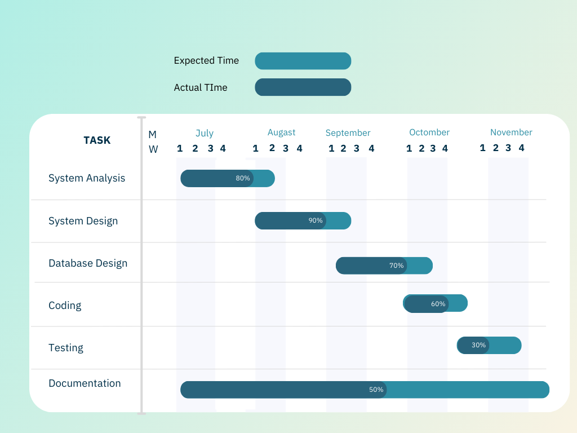

* 1. **Hardware Requirements Hardware Used:**
     + Only the recommended configuration (basic requirements of a computer system).

### Software Requirements MERN STACK

* + - **MongoDB**: NoSQL database for storing product and user information.
    - **Express.js**: Backend framework for building the server-side logic.
    - **React.js**: Frontend library for building the user interface.
    - **Node.js**: JavaScript runtime for executing server-side code.

### Tools Used:

* + - Report Viewer
    - STAR UML Diagram Tool
    - MS Word
    - Visual Studio Code
    - MongoDB ATLAS

### Preliminary Product Description

The system is divided into two main modules:

1. **Employer Module:** This module allows administrators to add, update, and delete job postings and manage categories. Admins have exclusive access to this module, enabling them to oversee job listings and ensure the platform remains current with available opportunities.
2. **User Module:** This module is designed for registered users (job seekers) and includes features such as browsing job listings, applying for positions, saving jobs, and managing their application history. Users must be logged in to access these functionalities, ensuring a personalized experience.
   1. **ER And UML Diagrams ER Diagram**

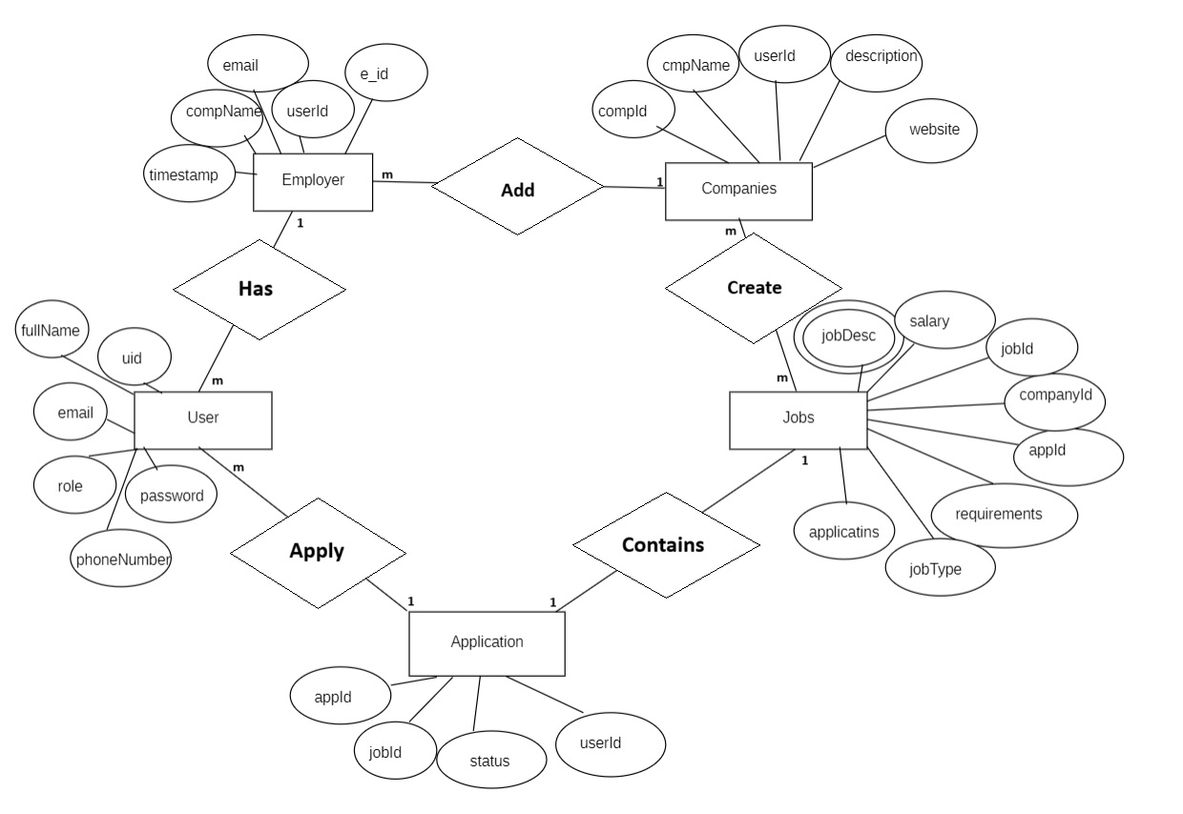

**Use Case Diagram**

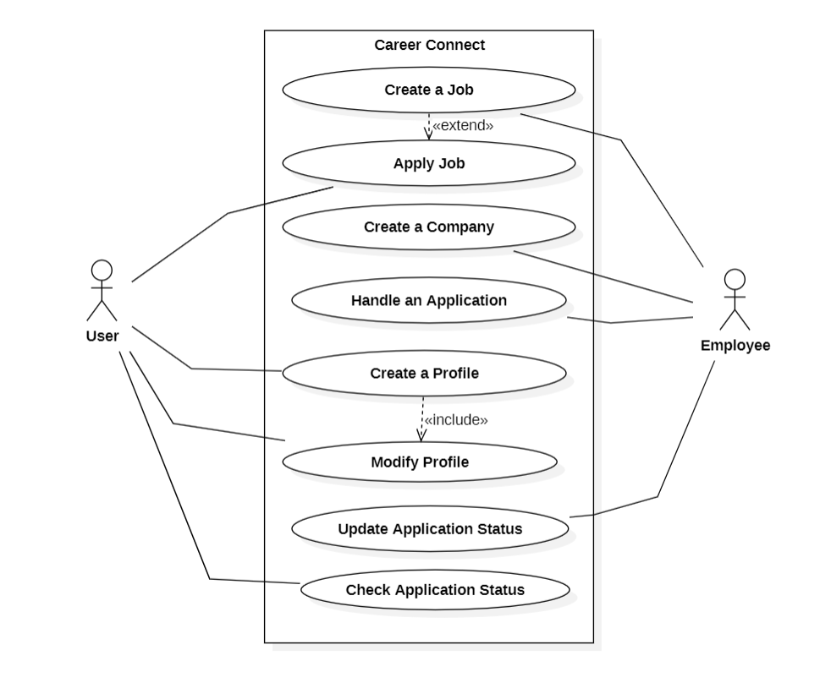

Employer

### Activity Diagram

Employer Activity

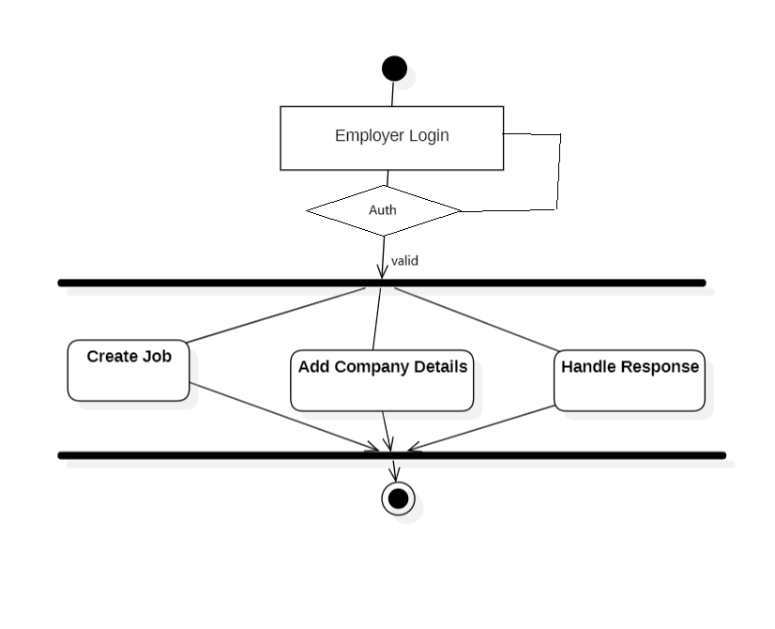

User Activity

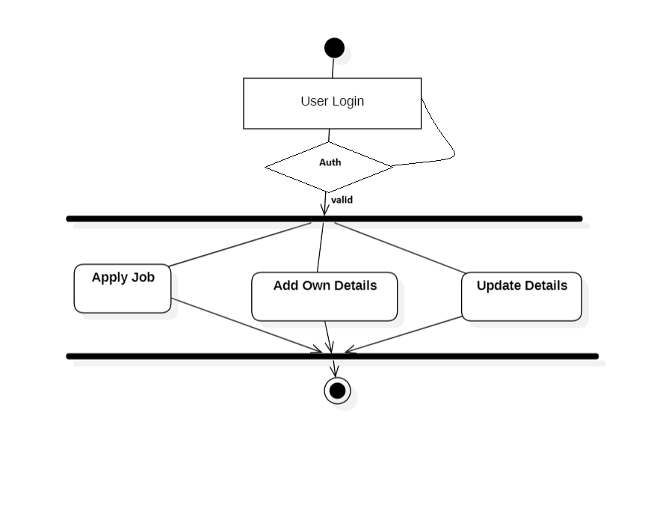

### Sequence Diagram

Genral sequence

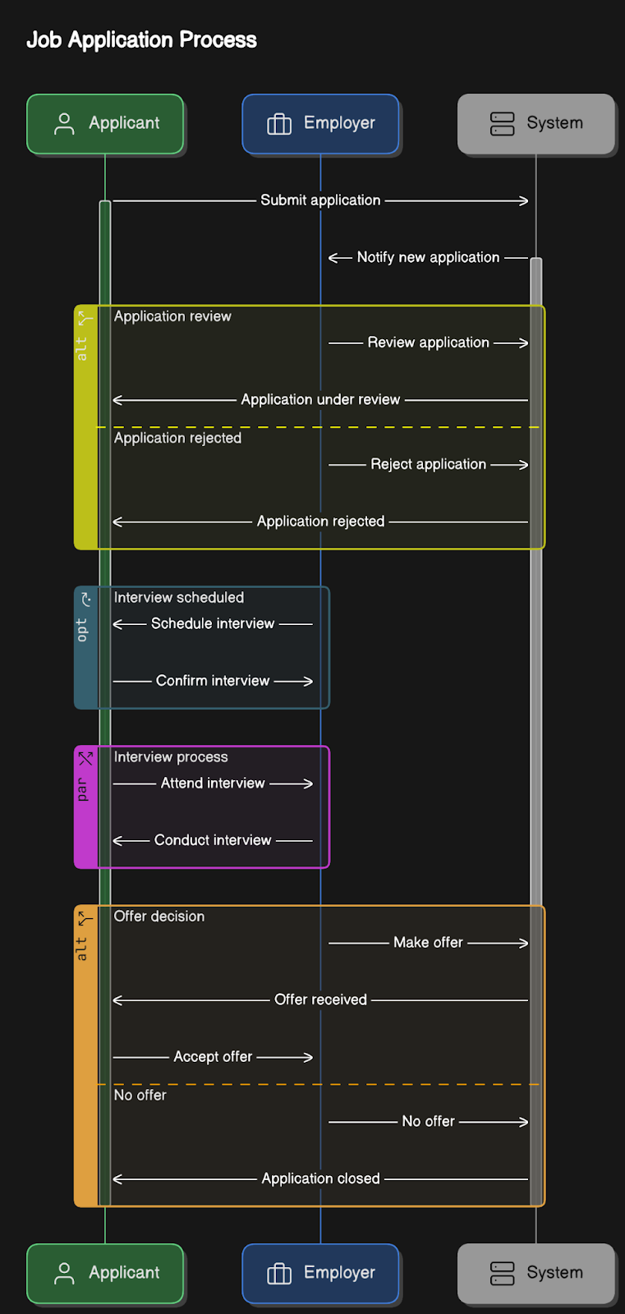

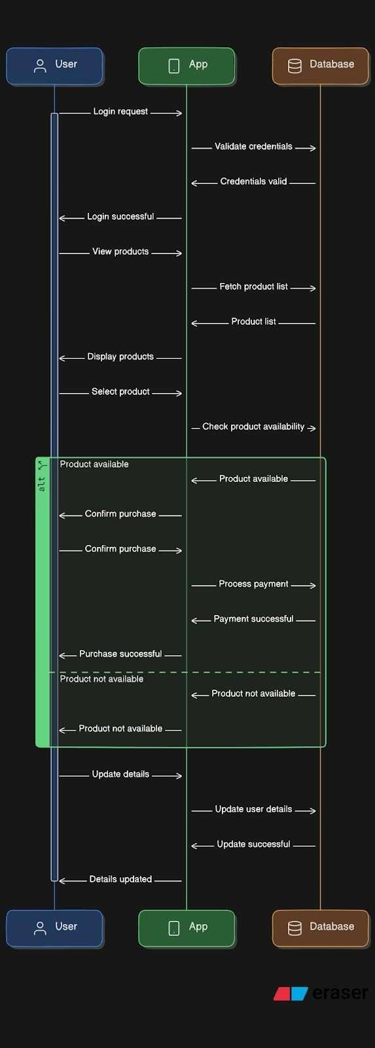User Sequence

1. **System Design**

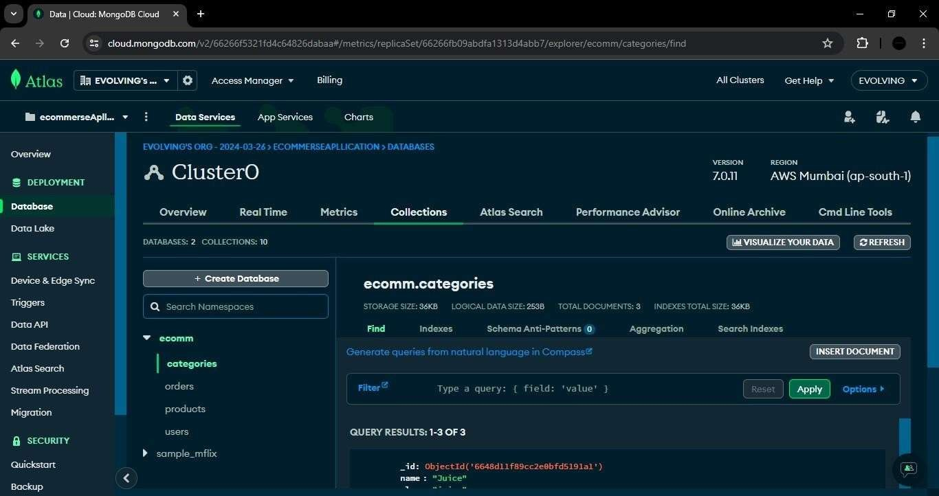

### UI Design

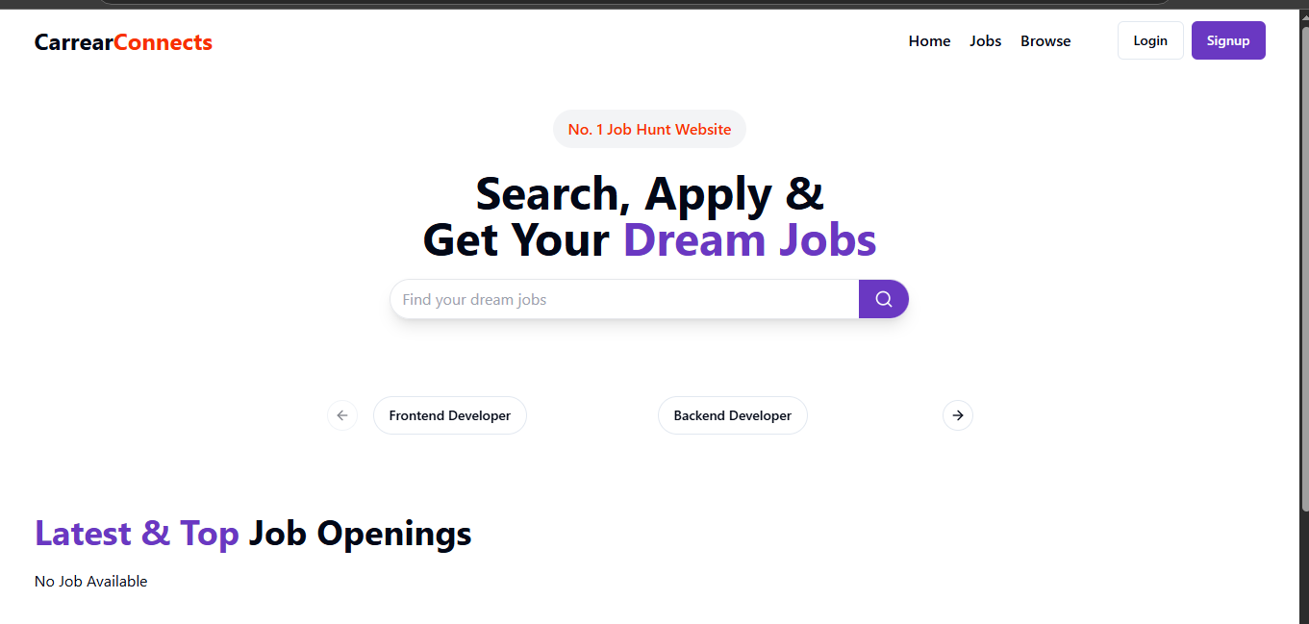

* + 1. **Homepage:**

**4.1.1 Homepage**



**4.1.2 Registration :**

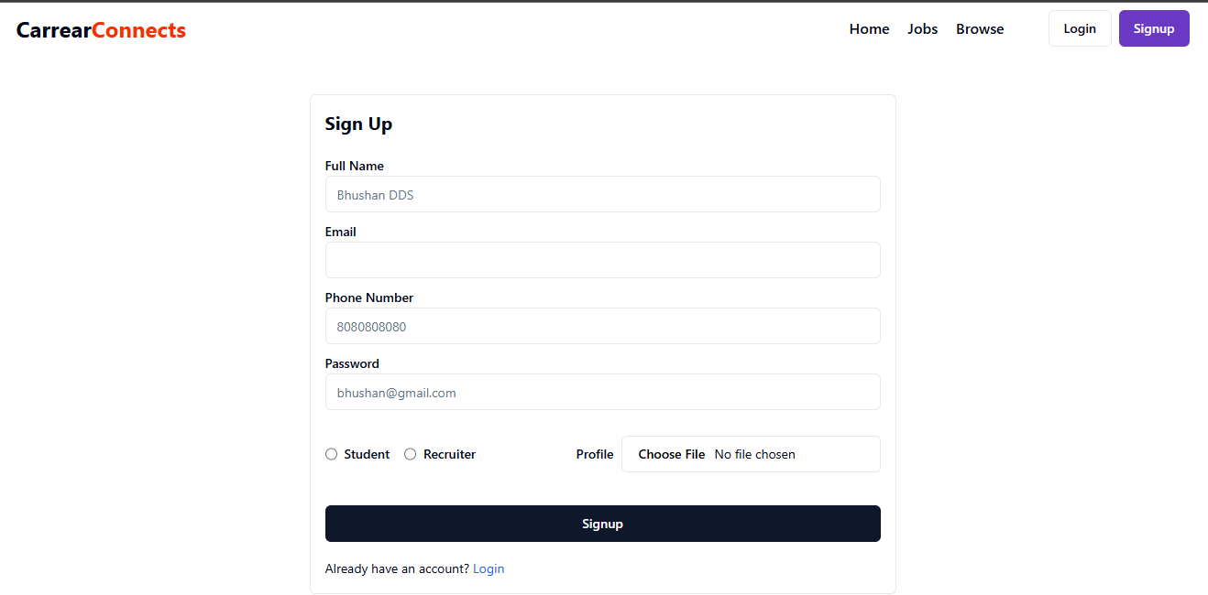

* + 1. **Login Page**

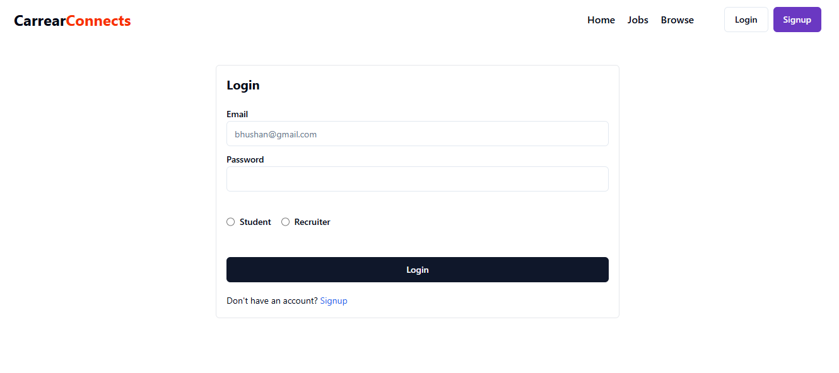

**4.1.4 Job Details :**

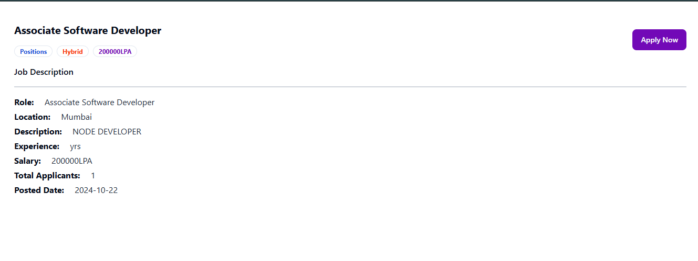

**4.1.5 Employer Details**

**Recruiters Dashboard :**

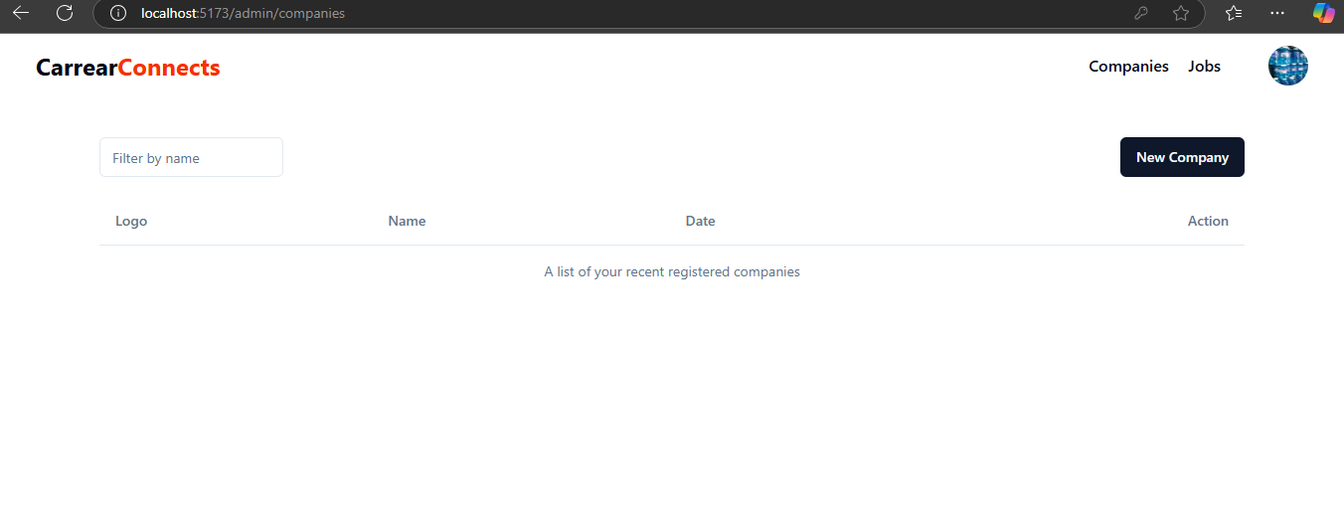

**Add Company :**

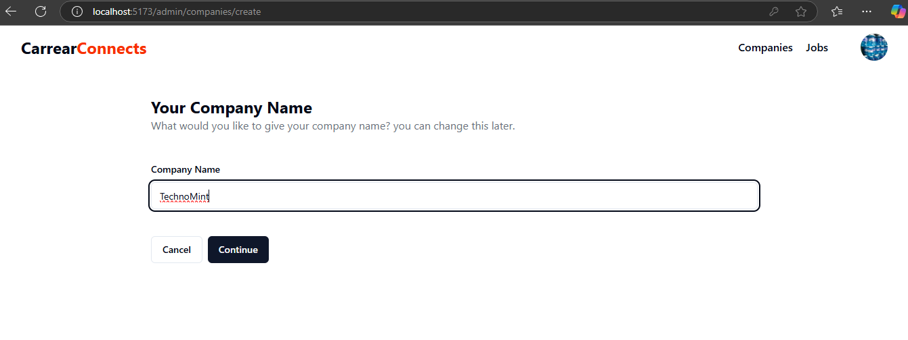

**Add Company Description:**

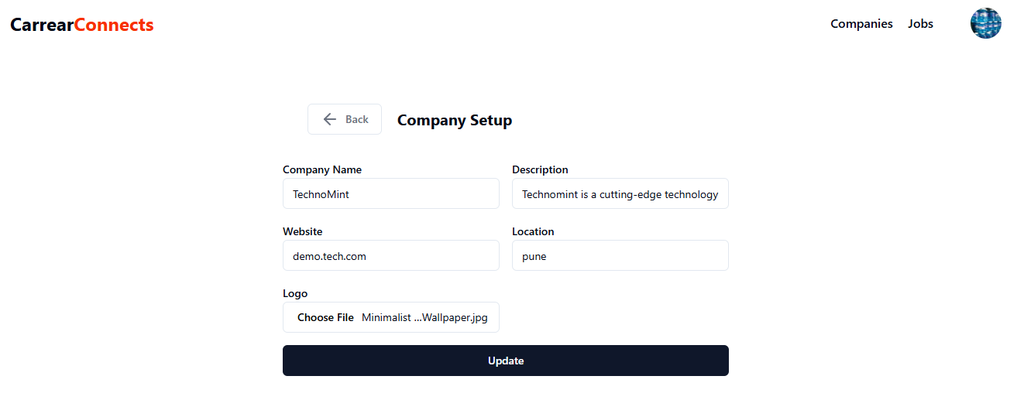

**Company Added :**

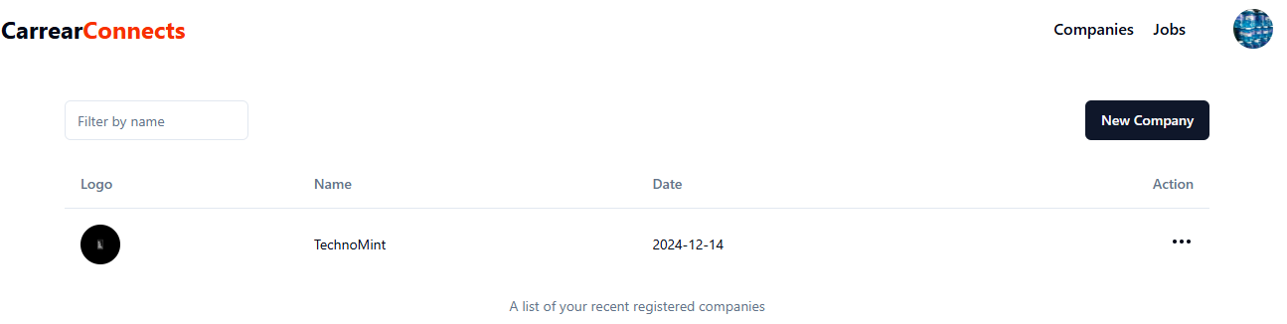

**Adding Job :**

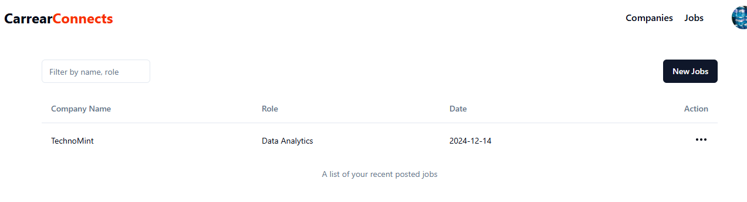

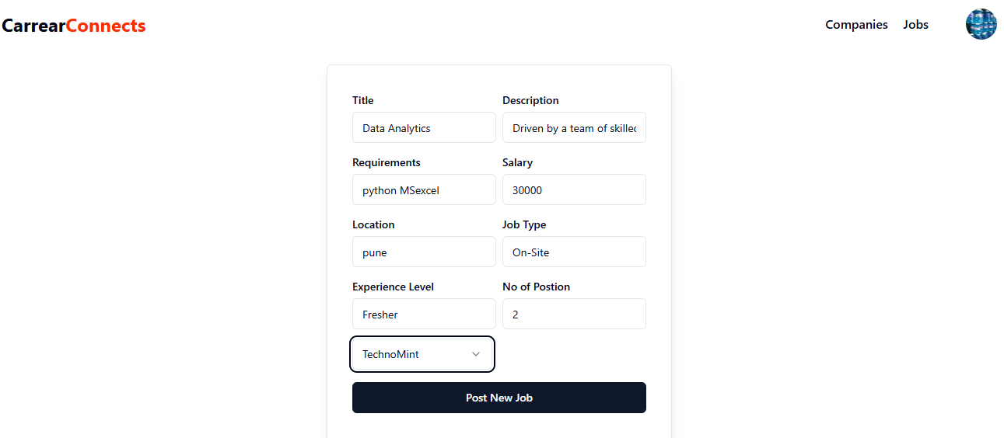

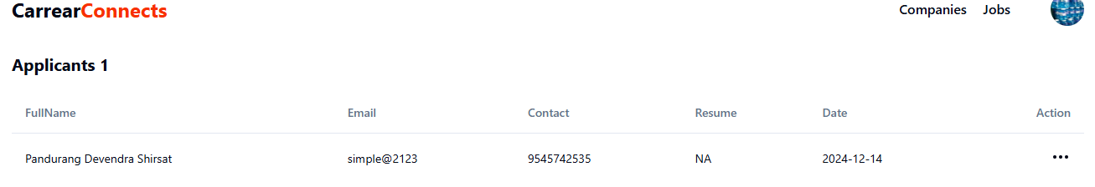

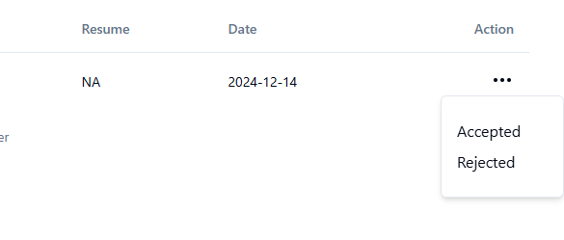

* + 1. **User**

**User Dashboard:**

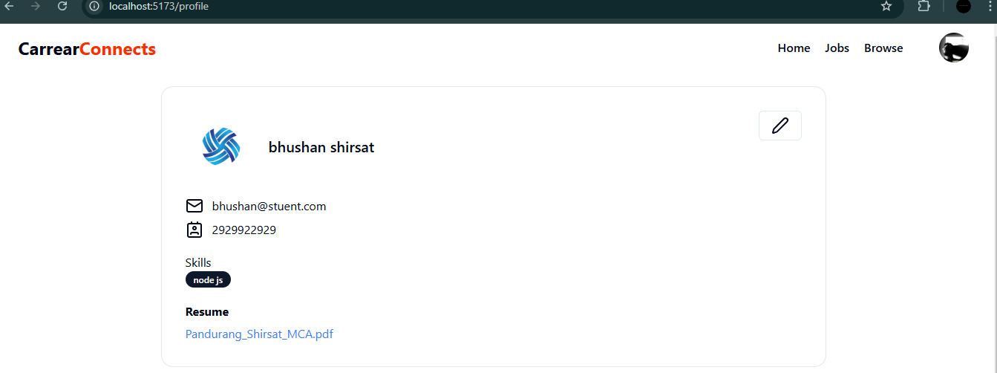

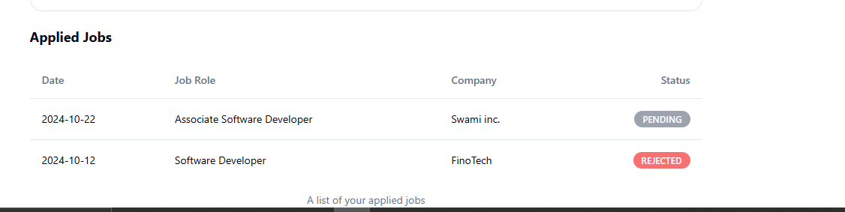

**Update User Profile:**

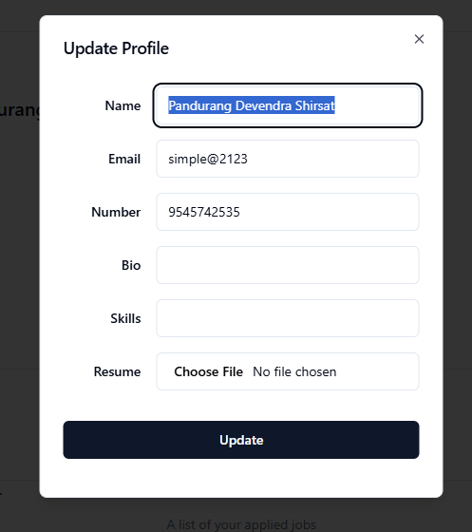

**4.2 Test Cases**

**4.2.1 Login:**

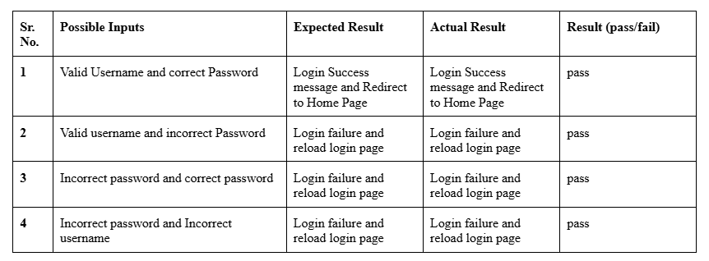

**4.2.2 Registration:**

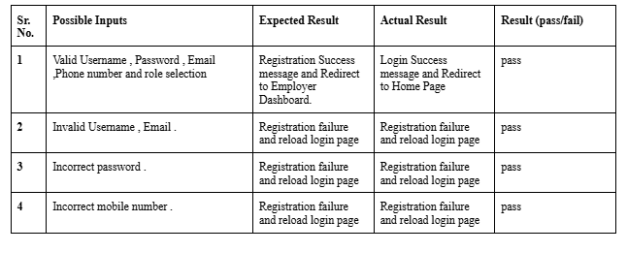

**4.2.3 Create Company:**

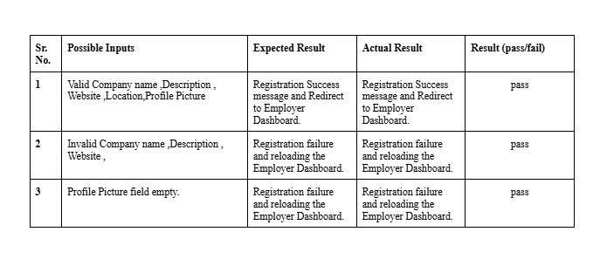

**4.2.4 Create job:**

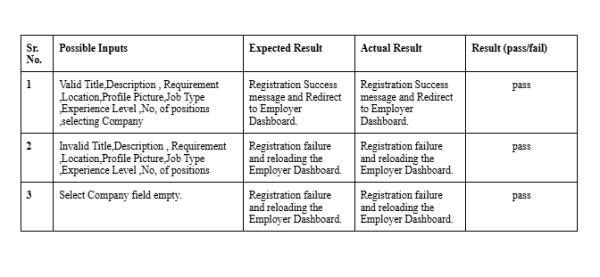

* + 1. **Check applications:**

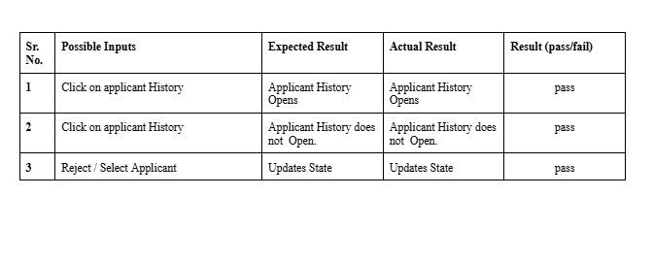

**4.2.6 Apply for the job:**

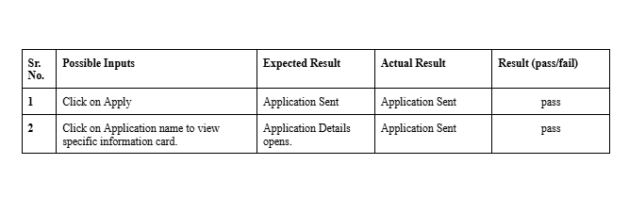

**4.2.7 Update User Profile:**

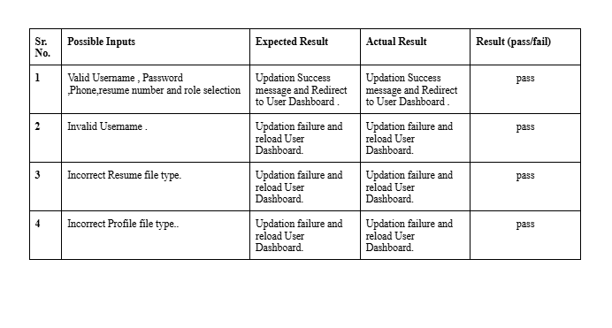

**4.2.8 Update Company details:**

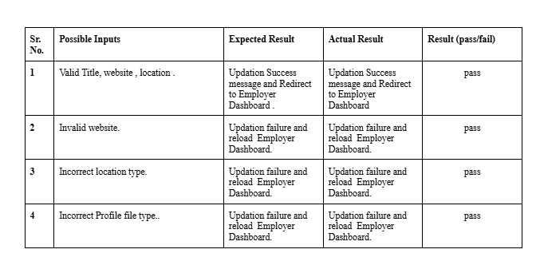

**5. Limitation and Future Enhancements**

**Limitations**

1. Limited Payment Integration
   * The project may have basic payment gateway integration. Supporting multiple payment gateways and ensuring secure transactions could be enhanced.
2. Basic UI/UX Design
   * While the UI is functional, it might lack advanced user interface designs and user experience optimizations. Professional UI/UX design improvements could significantly enhance user satisfaction.
3. Manual Application Management

-Application management might be manually handled. Automated application updates and notifications for low stock levels are not implemented

**Future Enhancements:**

1] Comprehensive Payment Integration 2] Improved UI/UX

3] Automated Application Management 4] Mobile Application

**6.BIBILOGRAPHY**

1. https://stackoverflow.com/questions/tagged/reactjs
2. https://[www.w3schools.com/react/](http://www.w3schools.com/react/)
3. https://chaicode.com/reactJS
4. www.youtube.com/@TechinfoYT